**OneCareer DS-XL 2023 Final Report - Group 3**

😎Product Manager: Haibo Yu

🙌Team: Di Zhang, Runze Wang, Zikun Shangguan, Eric Xue, Jill Tan, Yanzi Wu

**Meet Fresh Two-Layered Recommendation: An Ingredient-Based Personalization Experience**

## ✨Business Case

As Meet Fresh embarks on its ambitious expansion in the overseas market, it becomes more critical than ever to meet and exceed customer expectations and bring delightful Meet Fresh experience to more customers around the world. Other than business strategies such as creative marketing and rolling out niche products, one effective way to accomplish this is enhancing customer experience by addressing the most impactful customer need that truly brings value to Meet Fresh and its customers.

Through a series of product design stages, we successfully identified the most critical customer needs that guided our solution design. A key opportunity lies in offering a **smoother** and **easier** ordering experience that highlights **personalized recommendations** based on customer preferences.

With Meet Fresh’s wide variety of dessert options, customers commonly find it overwhelming to navigate the ordering process and discover what they might enjoy, much more so for non-native, non-Chinese-speaking customers. In order for Meet Fresh to continuously delight new customers and build up a loyal customer base in international markets, it becomes crucial to bring a solution that directly addresses the unique challenges customers face outside of Meet Fresh’s domestic markets.

We would like to propose an **ingredient-based personalization experience** that could be integrated into the existing Meet Fresh ordering experience. We see significant impact and value in this **customer-centric** solution for the following compelling reasons:

1. **😃Delightful Customer Experience**: An ingredient-based recommendation system leverages customer preferences and delivers personalized and targeted recommendations to customers. This enables smoother and easier decision-making processes that reduce customer frustration and friction.
2. **💰Increased Revenue and Upselling/Cross-selling Opportunities**: Delivering complementary or supplementary products to customers guides customers to discover more products that they might potentially enjoy. A great product recommendation diversifies customer choices, increases relevant product exposures, and as a result, increases chance of purchase and profitability.
3. **💪On-Brand Competitiveness**: Meet Fresh’s unique brand image is what sets itself apart from other competitors. Highlighting **exquisite**, **high-quality** and **authentic ingredients**, Meet Fresh has established itself as the quintessential Taiwanese dessert-maker. An ingredient-based recommendation system not only highlights the beloved ingredients at the heart of Meet Fresh’s brand perception, it further strengthens Meet Fresh’s position as a customer-centric brand that understands, respects and celebrates individual customer preferences.

## ❤️Overview of UX Design

Here’s an overview of the UI components (the UI is currently rendered in a website, access [here](https://haiboyu2628.wixsite.com/meet-fresh/)) -

1. Home
   1. Subscription
   2. Comments
2. Our Shops
   1. Maps (Plano shop)
   2. Social Media (US shop)
3. Full Menu
   1. A list of all products
   2. Product text and image descriptions
4. Signature Series
   1. A list of signature series products only
   2. Text and image descriptions of signature series products
5. Discover Ingredients
   1. A list of available ingredients with text and image descriptions
   2. Rating board
   3. Allergic record
6. Recommended Ingredients
   1. A list of rated ingredients
   2. A list of recommended ingredients based on customer rating
7. Recommended Products (in multiple tabs with different recommendation algorithms)
   1. Picked for you based on your preference
   2. Trending Populars

The following outlines a walkthrough of user interactions with the components -

1. **Home**: users can subscribe to our news, promos and activities by email or social media. They can also leave a comment regarding our shops, our food, or anything else.
2. **Our Shops**: users can see contacts, maps and directions of the Meet Fresh Plano, TX location site. This page is used to highlight the store location.
3. **Full Menu**: users can view and order products from the full menu, just like today’s ordering experience. We provide a brief text description under every product image.
4. **Signatures**: users can order from Meet Fresh’s Signature Series products.
5. **⭐Discover Ingredients**: by selecting this option, users trigger the recommendation engine. From here, users provide ratings for available ingredients in the shop. These ratings, together with other data, are then used to generate personalized recommendations. There are options for users to indicate any food allergies and dietary restrictions as well.
6. **Recommended Ingredients**: Based on customer ratings and other data, ingredient-level recommendations are provided in this step; users could select additional ingredients they like from the list of ingredients recommendations.
7. **Recommended Products**: Multiple tabs could be displayed to users, depending on the recommendation algorithm we implement. We propose the following to get started:
   1. Picked for you based on your preference - recommendations based on customer ingredient selections and product + ingredient data
   2. New and popular - seasonal/new products sorted by total sales within a defined look-back window (i.e. last 30 days)Lucid Lucid Lucid

Users then select product(s) and add to cart from here before proceeding to the checkout stage.

## 📊Data Enablement

We conducted extensive data enablement work to enrich, simulate and assemble data needed for prototyping our technical solution. The detailed process could be accessed in [this comprehensive technical documentation](https://docs.google.com/document/d/1NYDL-yYXWI4TNYNDPX3H8wOTHzmXXc9oXx0j7LU10Os/edit?usp=sharing) under the “Data Enablement” section. We identified the following required data for building our solution -

1. 2022 store sales data for Meet Fresh location in Plano, Texas (provided by Meet Fresh)
2. ingredient and product item attribute data (requires data collection efforts)
3. customer-level rating data (scaled 1-3) for each ingredient (requires external mock data)

### I. Store Sales Data

The only data provided directly by Meet Fresh SME is 2022 store sales data for store location in Plano, Texas. Raw data was provided in pdf format, and data extraction and cleaning was performed to convert data into tabular format and stored in BigQuery on Google Cloud Platform.

The table schema looks like -

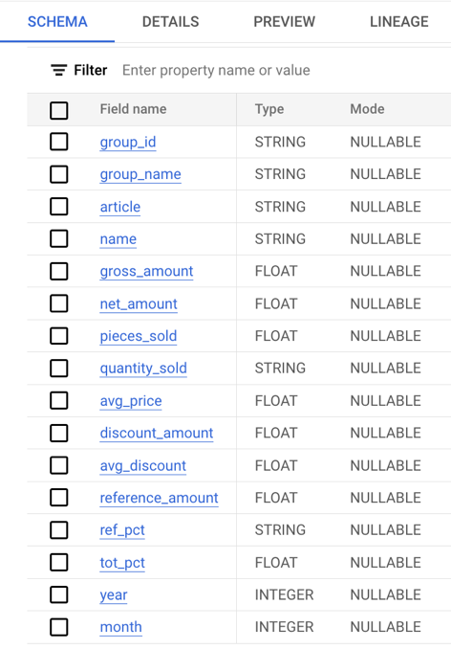

Here’s a sample of the store sales dataset -

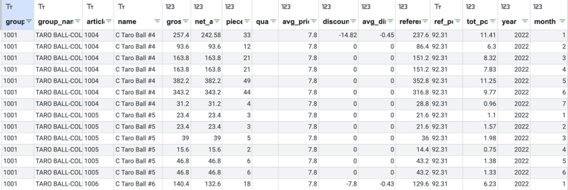

### II. Ingredient, Product Item Attribute Data

Ingredient-level and product-level item attribute data were collected from [Meet Fresh USA site](https://meetfresh.us/menu/). The following steps were conducted for initial data processing -

1. Data enrichment was done for items missing descriptions using ChatGPT
2. Primary key mapping (ingredient_id, product_id) was done for dim_ingredient and dim_product tables, using values from store sales data

The table schema looks like -

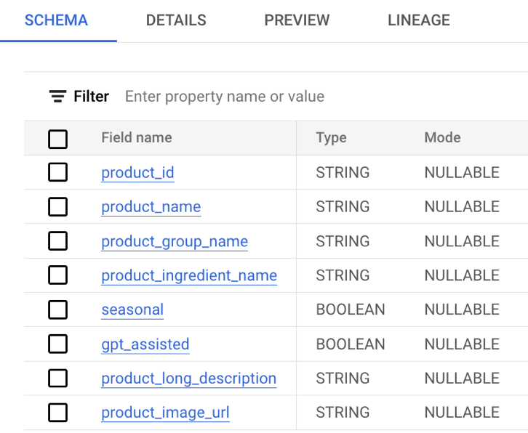

Here’s a sample of ingredient dataset and product dataset:

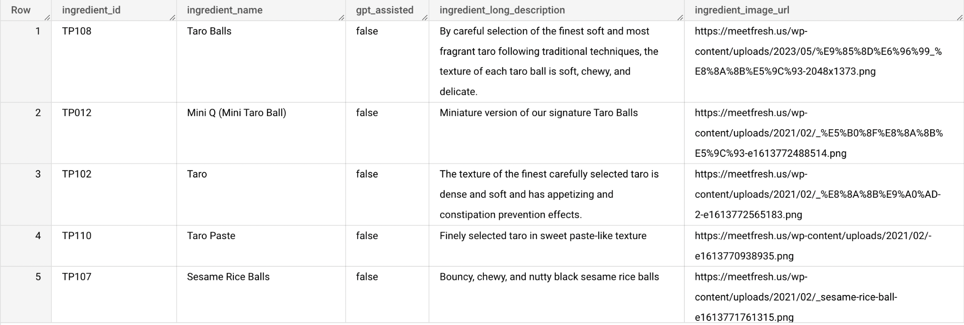

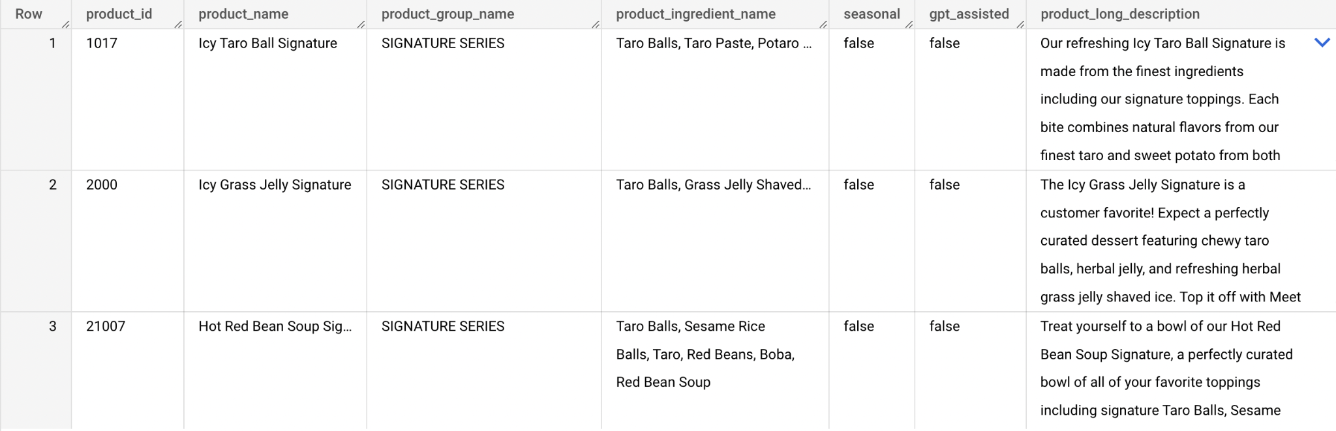

### III. Customer Ratings Data

In order to leverage collaborative filtering algorithms for our recommendation systems, customer-level rating data is needed. This type of data doesn’t currently exist at Meet Fresh. Thus we utilized mock data that is adapted to Meet Fresh context.

We explored [Amazon review data](https://nijianmo.github.io/amazon/index.html#sample-review) and [Movies data](https://www.kaggle.com/datasets/rounakbanik/the-movies-dataset?resource=download&select=ratings.csv), and decided on using Movies data as our basis for generating our Meet Fresh mock data. See “III. Customer-Level Rating Data” section in [this documentation](https://docs.google.com/document/d/1NYDL-yYXWI4TNYNDPX3H8wOTHzmXXc9oXx0j7LU10Os/edit?usp=sharing) for full details.

We performed stratified sampling based on aggregated 2022 sales quantity distribution for each ingredient. Our mock data was then stored in a BigQuery data table. A sample of this dataset is as follows -

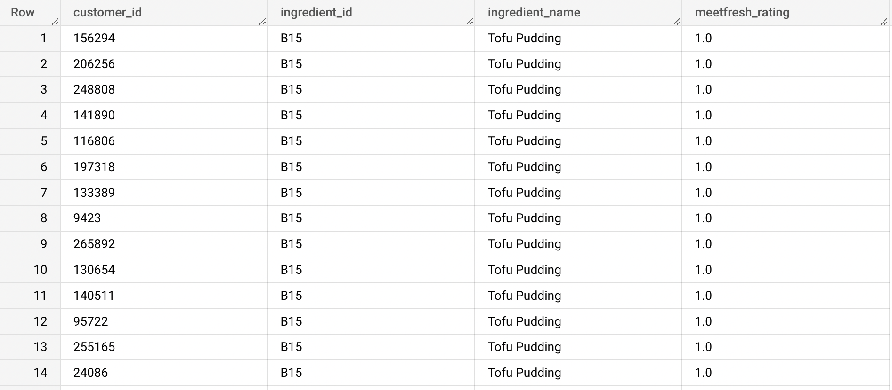

## 🤖Overview of Technical Design

The core of the ingredient-based recommendation system solution lies in its **two-layered** **recommendations** - ingredient-level and product-level. Meet Fresh’s signature products consist of a combination of ingredients. Very often, non-native, non-Chinese-speaking customers generally have little background knowledge about these ingredients, and as a result, face challenges of not knowing what they might enjoy. Our technical design aims at helping customers discover their dessert preferences by the following two steps:

1. **ingredient-level**: introducing and surfacing ingredients that customers might like
2. **product-level**: providing product-level recommendations based on customer ingredient preferences

The rationale behind our technical design for the two-layered recommendation system is outlined below (detailed technical documentations could be found [here](https://drive.google.com/drive/folders/1n7YD0k7jS7jYGkR2joxjcirzoWfZUmbt?usp=drive_link)) -

**🌱Ingredient-level**

1. ingredient-level recommendations address the common challenges to customers who find Meet Fresh menu overwhelming and need an easy start finding **what else they might like**, given the few ingredients they know they like
2. customers directly rate ingredients so we have **explicit rating data** to construct a customer-ingredient rating matrix
3. given the finite and limited selection of ingredients, we want to focus on expanding customer existing preferences; **collaborative filtering** is a well suited approach for this purpose
4. alternatively, we explore generating embeddings (custom-trained or pre-trained) for ingredients based on their text descriptions, and use the trained embeddings to find ingredient embeddings. Together with the customer-ingredient rating matrix, we leverage **content-based filtering** for generating ingredient recommendations

**🪴Product-level**

Given customers’ ingredient selections, we now have an understanding of their ingredient preferences and could move on to product-level recommendations. Multiple options are considered here, and our UI design accommodates the placement of multiple types of recommendation lists.

1. **approach #1**: since a combination of ingredients describes each product, we simply use ingredients as product features, and the customer-ingredient rating matrix to compute similarity measures to rank products and recommend to customers -> **picked for you based on your preference**
2. **approach #2**: to complement the previous approach, offer all new products sorted by total sales within a defined look-back window -> **new and popular**
3. **approach #3**: derived from approach #2, but a more personalized selection of new products, leveraging customer-ingredient rating matrix and product ingredient features for new products -> **something new that you might like**

The following diagram summarizes the technical design of the two-layered recommendation engine -

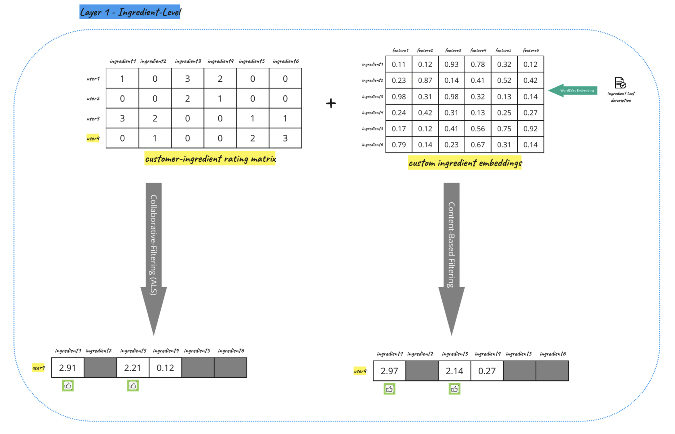

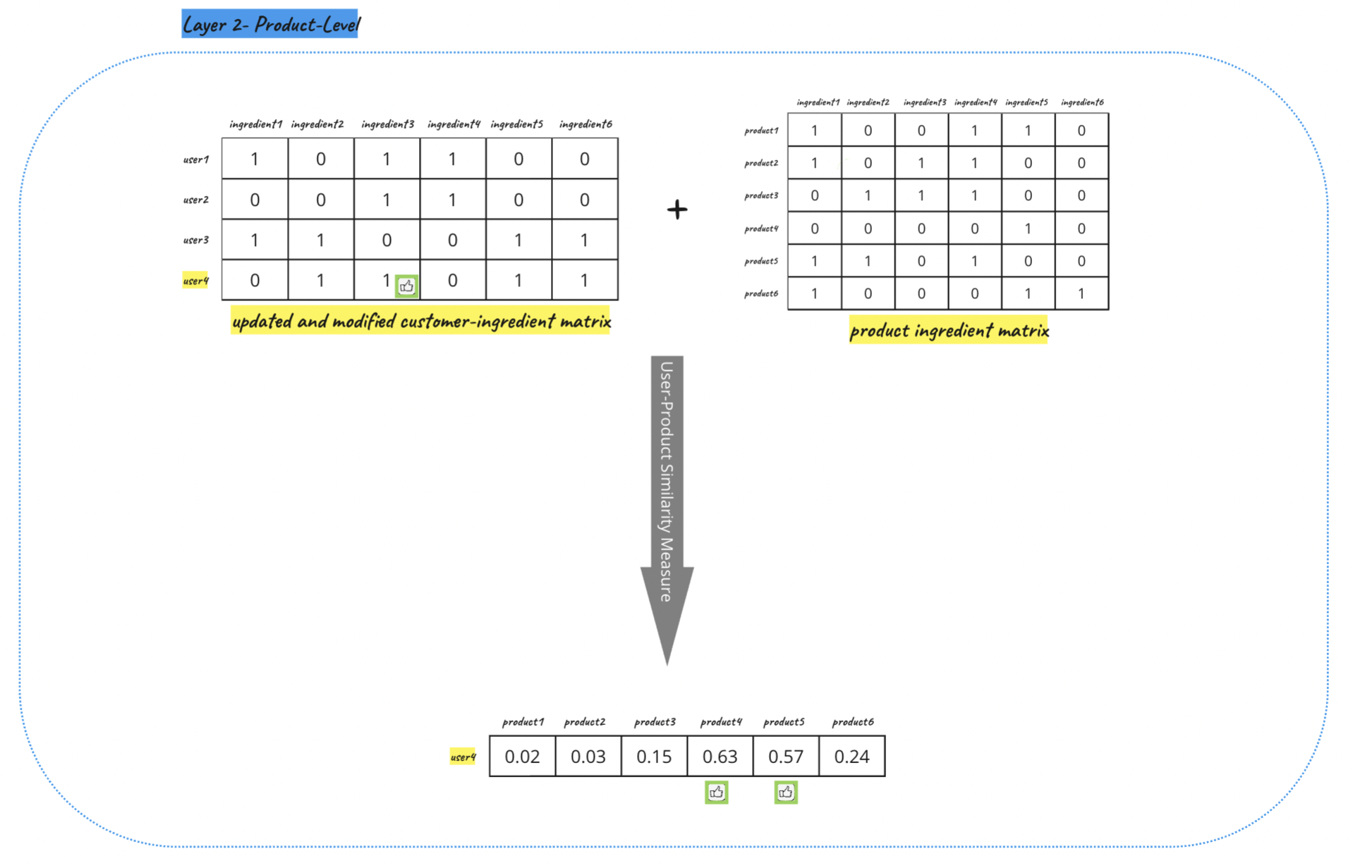

## 📐Solution Evaluation

### I. Offline Evaluation

In order to assess the performance of our recommendation models, an offline evaluation was conducted using the data provided by Meet Fresh and the mock rating data. This section presents the evaluation process, including the datasets and metrics used, and how we obtain the result from evaluation.

**Precision:** This metric measures how accurate the recommended items are, that is the proportion of relevant recommendations in the top-N list. We are using top-5 suggestions and we can get roughly 60% precision.

**RMSE:** The difference between actual data and the results calculated by our system.

**Coverage:** The number of items that can be recommended among all items.

**Customized metrics**: Customized Scores to evaluate the model. We got an accurate score at 69.67%.

### II. Online Evaluation

After release, we will use other metrics to evaluate the business impact of the model and the system:

**Hit Rate**: The percentage of users that clicked recommended items.

**Time on Page**: The time users spend on the website and each page.

**Click Through Rate**: Number of interactions over number of shows.

**Conversion Rate**: Number of conversions over number of interactions

**Effects on Sales Distribution**: The average of sales differences.

## 📝User Feedback Insights

Please refer to [this documentation](https://docs.google.com/document/d/1fcyRh_FZzNiesL6IoE5EGsNwbYsWP89wJzbkpB8JC48/edit?usp=sharing) for full details from user feedback interviews.

### I. User Feedback

1. 在使用我们的订餐系统时体验很不错，易于使用
2. 通过我们的推荐系统，可以得到了满意的食物推荐.
3. 菜单分类和展示方式非常直观，在”**Signatures**“部分也可以分类展示
4. “Discover Ingredients”和“Suggested Items”界面中的评分体验非常棒，评分对于提供个性化的推荐非常有效并且便捷快速。
5. 很喜欢“Trending Populars”界面中的主流产品展示，特别喜欢根据季节推荐
6. 订餐系统提供了足够店铺的位置、营业时间，以及社交媒体联系等等信息。
7. 他的推荐方式让我眼前一亮，我很愿意让我的家人也体验一下

### II. New Opportunities

”**Our Shop**“ : 可以展示品牌理念，地点的右下角显示地点的文字信息。可以放一些线下店里的照片。

”**Full Menu**“： 每一个产品可以多放一些图，比如在同样的空间内用箭头滚动切换（切换成食材的图片）。可以加一个视图转换的功能，横条状与网格状的视图切换

”**Signature Series**“：Satisfaction Guarantee区域加一些广告类的东西如一些社交媒体评论关于美食，食材，门店，和服务。

”**Discover Ingredients**“： 加一个如何操作的解说，有些客户不知道如何与爱心桃互动。

”**Recommendations for You**” ： 图可以大一点，trending Part可以放在Signature Part。

**Overall：**

1. “Our Online Shop” 的色调和背景可以稍作修改
2. 可以在首页显眼处放一些营销性质的优惠活动。
3. “Let’s Chat!” 可以放在侧面有些设备这个按钮会挡住 ”Recommendations for You”。然后如果点餐过程在一个界面呆了太久的话可以显示一个红点在“Let’s Chat!”上，用户点后会看到“是否需要帮助”的对话框。

### III. Summary

Users have appreciated our food ordering system for its user-friendly interface and satisfying recommendations, finding the presentation and categorization of the menu, particularly in the 'Signatures' section, intuitive. They praised the rating experience in the 'Discover Ingredients' and 'Suggested Items' sections, finding it effective and convenient for personalizing recommendations. The display of mainstream products and seasonal recommendations in the 'Trending Populars' section has been well-received. Users also valued the provision of restaurant locations, operating hours, and social media contact details.

Simultaneously, there are opportunities for enhancement. For instance, in 'Our Shop', we could display the brand philosophy and add textual location information in the lower right corner, including photos from physical stores. In the 'Full Menu' section, more images can be added for each product, with a feature to toggle between list and grid views. The Satisfaction Guarantee area in the 'Signature Series' could be enhanced with promotional content like social media comments about the food, ingredients, store, and service.

Instructions on how to interact with the system could be added in 'Discover Ingredients'. For 'Recommendations for You', images can be larger, and the trending section could be placed in the Signature section. The color tone and background of 'Our Online Shop' can be slightly tweaked, and promotional offers can be displayed prominently on the homepage. Lastly, the 'Let's Chat!' button can be placed on the side to avoid blocking 'Recommendations for You' on some devices, and a 'Do you need help?' dialog box can appear if a user has been idle on a page for a while.

## 🔃 Future Iterations

Most of the customers gave feedback on the UI. This makes sense because users are most aware of the existence of UI, not the backends. So our improvements will be more likely on the UI.

Based on our own understanding of the ordering process, we also came up with some other feedback by ourselves. Here’s what we are planning to do -

1. To enable the “Add to Cart” function so that users can see what’s added.
2. To add a “Need Assistance” button on the upper left corner.
3. To put more introductions about Meet Fresh, or promos in Our Shops page.
4. To add Ads and Quotes from Social Media to the Signature Series page.
5. To enlarge the picture size in the Recommendations for You page.
6. To refine the layout of the components.